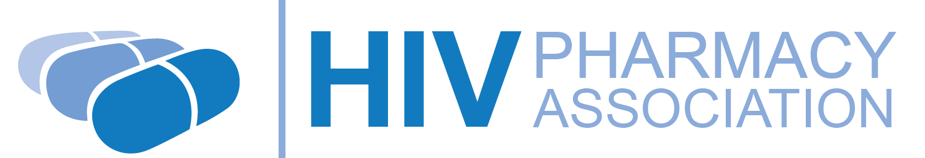
Important changes to your
Efavirenz (Sustiva®) 600mg tablets
Sustiva® is the brand name for one of the drugs you currently take called efavirenz. It is made by a company called Bristol-Myers Squibb (BMS). Efavirenz is the name of the ‘active’ drug in Sustiva, also known as its generic name. Check the Sustiva box and you will see it says efavirenz in smaller letters.

Other companies will now be making efavirenz tablets and these new tablets do not have a brand name. These are known as generic medicines.

From now on, the efavirenz tablet you receive from your clinic pharmacy or home delivery company will not be the Sustiva brand but a generic version of efavirenz tablets. Look for the name on the box, which will now say: Efavirenz 600mg tablets

Why is the NHS switching to generic medicines?
Generic medicines are just as carefully regulated and as effective as the originals, but are often significantly cheaper to the NHS. This means your clinic can continue to offer you the same high quality treatment and make cost savings, helping us look after our growing number of patients.

What will change?
The box the tablets come in will look different to the Sustiva box. The shape and size of the tablets may also be different.

How should I take the new efavirenz tablet?
Your doctor or pharmacist will speak to you if there is any difference in the way you need to take your tablets. Always read the label on the box before taking your medicines, even if you think you have had the medicines before.
Use up your current supply of Sustiva tablets first and then switch to the new efavirenz tablet at your next scheduled dose. Do not take the Sustiva and efavirenz tablets at the same time.

Will the new tablet work in the same way as Sustiva?
Yes. Both tablets have the same active drugs at the same doses. Continue to take the tablet as prescribed by your doctor and the new tablet should work as well as Sustiva has.

Will there be any side effects when I switch?
You shouldn’t expect any new side effects when you start taking the new tablet, as it contains the same active drug. Occasionally some people may experience some minor side effects when they take a different version of a tablet, but these should settle down. You may experience some vivid dreams or sleep disturbances for a few days after switching, but these should settle.

Speak to your doctor, pharmacist or nurse if you experience any new side effects.

If you have any questions about efavirenz or Sustiva, or questions about any of your medicines, please contact your doctor, nurse or pharmacist.

Contact:

Telephone number:

The small print: This leaflet was produced by the HIV Pharmacy Association (HIVPA) and NAM (www.aidsmap.com) (version 2, June 2014). You only need to read this leaflet if you are already taking Sustiva 600mg film-coated tablets and are going to change to a generic version. This leaflet does not replace the patient information leaflet issued with Sustiva tablets or with generic efavirenz tablets, but you should read it in conjunction with them. This leaflet does not constitute any endorsement of the use of Sustiva or efavirenz tablets by HIVPA or NAM, and is intended for information purposes only. This leaflet is only designed for use with the United Kingdom and Ireland.

